Title
Your name, names of all lab partners (if any)
(no need for a cover sheet, name of instructor or class name as you submit this to the right class and section and the date is the submission date, but you can include one)
(Lab outcomes: Learn how to use and practice Tracker software for the data collection from video processing needed for lab activities.)

Abstract
This document outlines the format of the lab report and describes the Tracker assignment. The information here in part duplicates the lab 1 manual as some students may start with this activity first. The abstract should be a short paragraph that very briefly includes the experiment objective, method, result and conclusion. After skimming the abstract, the reader should be able to decide whether they want to keep reading your work. Both the format of the report and the error analysis are to be followed. Note that abstract is not just the introduction and conclusion combined, but rather the whole experiment in short including the results.

Introduction
This section should normally start with some background information on the topic of the lab. Historical background is fine, such as the history of discovery or first measurement of the value, etc. The motivation for doing the experiment should follow. Try to avoid separate statement of objective, hypothesis or similar. The motivation paragraph should logically conclude with the necessity of the experiment.
The main purpose of a lab report that you should always keep in mind is the sufficient description of the experiment so that someone else outside of this class will be able to repeat your work, and sufficient analysis and results description so that the result can be compared to other experiments and possibly the accepted value.
Tracker ™ is a useful tool to process the video files and obtain useful data for further analysis. This software will be used extensively throughout the first and second semesters of this course, so it’s worthwhile investing some time in learning its features now.
Note how the introduction contains the motivation for the experiment. Don’t use any statement like ‘hypothesis’ etc. Motivation can be placed in the Introduction or in a separate Motivation section and should outline reasons why the experiment is important, and the result is interesting and useful (with possible real-life examples). Do not use phrases like “this work is needed for the class” and similar!

Experimental Setup
Normally, this section describes the experimental setup and should include the photo or a schematic of the setup as well as the text description and the experimental procedure. The schematic can be very simple, such as shown in Figure 1. Briefly describe all the parts of your figure. Descriptions like Figure 1a or Figure 1 (left) can be used. Note the formatting of the figure reference and the caption. No colored text unless required by context.
Ruler
Object
b)

a)
Figure 1: The experimental setup schematic. A ruler (a) is used to measure the object (b).
The list and details of each section in the lab report are outlined in Table 1. Not every report might contain all sections, but abstract, introduction and conclusion are always present no matter what! Note that you should not use any words like below, above, last page, etc. The reference to the table, figure, equation, and other numbered items is the only indication where to find the information. The IEEE format should be used for references, such as [1]. The equipment manufacturer may be referenced like [2]. You can have two or more references in a row, for example: [1], [3]. Allow word processing software to do all the numbering and formatting! For the online labs, the relevant screenshot should be used, such as in Figure 2.
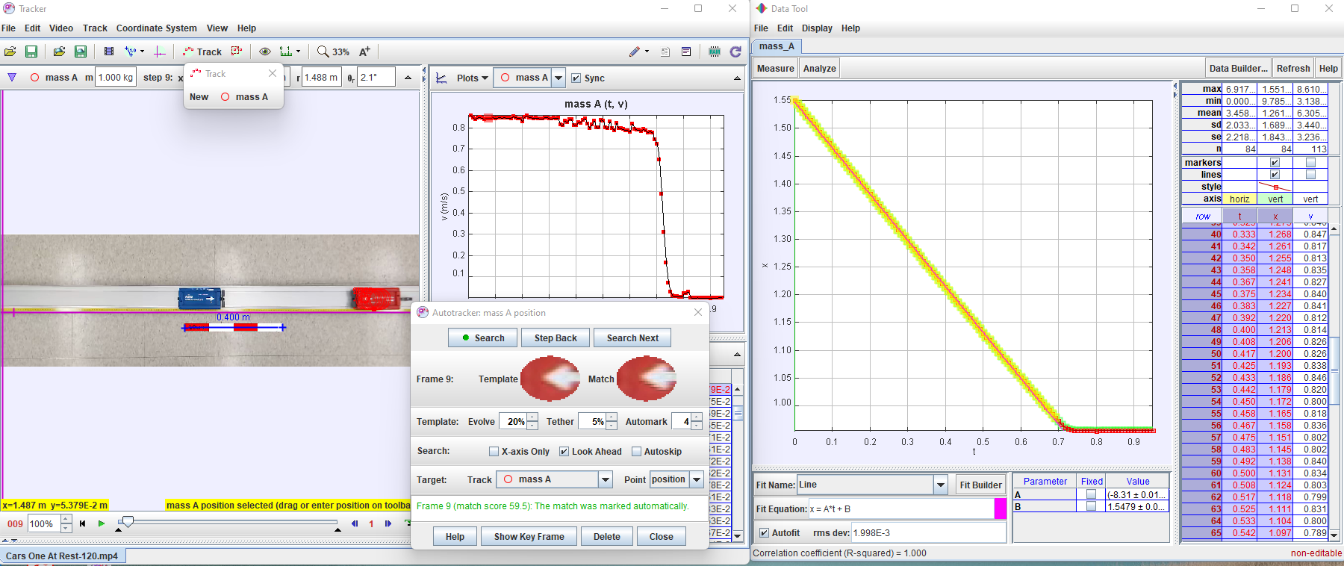
Figure 2: relevant part of the screen! Type some description, such as: The initial settings for the plot are shown. Here – the Tracker screen with the object being tracked, scale, object mass and the plot fit.

Table 1: Description of all parts of the report.
Section name | Section content description
Abstract | This is a short summary of the whole report, including the introduction, results, and the conclusion.
Introduction | Give an introduction into the topic of the lab and why are you doing it.
Experimental Setup | Can be also Experiment design, Setup and design, Apparatus, or anything similar. Includes the description of the apparatus used, or the experiment itself with all relevant schematics of the experimental setup. For Tracker labs, a relevant screenshot can be used.
Experimental Results (or Data) | Includes relevant tables (just one per each data type)/graphs of your data. Most likely, this is not raw values but averages with errors or similar. If you have more tables of the same, show only one - do not include the rest in the body of the report, but attach an Appendix at the very end.
Theory/Derivations | Either name is fine. If the lab asks you to derive any equation, or you need to use a set of specific equations, list and describe them here. A separate Derivations section in addition to theory (or as a subsection) can be used if a lengthy derivation is needed from the stated theory. Remember to number all the equations. Do not list equations that are considered ‘common’ knowledge, such as how to find mean or standard deviation. Sometimes such equation should be listed if it’s used explicitly in your calculations.
Analysis | Describe analysis process referring to equations from theory section. Show only organized results (for example, as a table or a plot, etc.). Describe what they are and what do they mean. You may show highlights of some steps of the calculation for a single example if you feel it’s necessary to be shown in detail.  Unless the focus is on the error analysis, it should be included in this section and not separated. ALL LABS SHOULD HAVE ERROR ANALYSIS even if the manual doesn’t directly instruct you to do so.
Conclusion | Restate the result with appropriate errors and comment on it. Or refer to the plot or table with the results if longer than one-two numbers. Comments/discussion should include if the experiment was a success, if the value is near the expected, what was the reason for any deviation and can this experiment be improved if done again.
References | Use IEEE format for the references. You can use reference as part of the text, such as: As described in [1], the result matches with the value from [2] and so on. Avoid quoting actual text from references or keep to as little as possible.
Appendix | Can be Appendix 1, Appendix 2 as needed. Can include anything you wanted to show but it was lengthy or didn’t fit into all previous sections. Normally, you should try to avoid adding an appendix but its ok to include one to your report.

Procedure:
You can include a separate subsection for the procedure, or you can make it a part of the text in this section, in any case, don’t write it as a cookbook, rather explain and comment on each step as needed. The manual in most cases will provide procedure in a different format, don’t copy!
For this lab, you should first download the video provided by the instructor. Make sure that its not a .zip archive but actual video (extract the video if needed, this will depend on the operating system you are using). Watch the instructional video on Tracker that is provided and remember that there are many other resources available on YouTube and other platforms.
Find the body in the video that your section was assigned to track (may be different from the one in Figure 2). Set up the scale, axes, and the body footprint (circle is best, it can be resized later as needed). The x-axis must be along the motion. Indicate the point that will be tracked and run the search.
From the resulting data, select the part of the linear motion that the body is moving freely (or under some negligible friction). Do the fit of this x-position data vs. time using Tracker, not excel or other software. The Tracker fitter provides the error on the fit parameters – what you want is the velocity with its associated error. If fit parameters are 0, check the Autofit option!
Now, back on the main Tracker screen, change the plot from position vs time to x component of velocity vs. time. Start the analysis screen, but instead of fitting just find the average and stdev of the selected region similar to Figure 3 – again, your plot may be very different from the example.
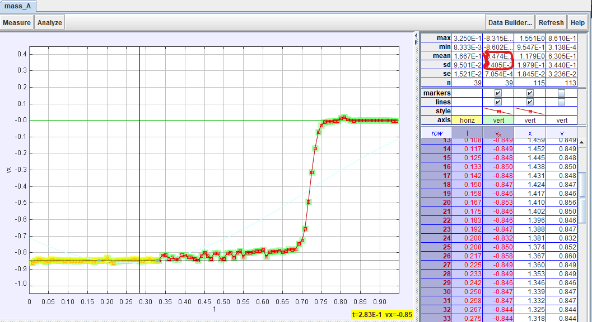
Figure 3: The average and stdev (or sd) for the highlighted velocity data.
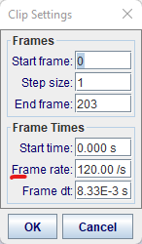
Compare the velocity from your fit and from this average within errors. Which one is more accurate in your view? What can be done to improve the results? Comment on that in conclusion.

Some additional considerations to check when working with Tracker:
(note – the formatting in this subsection is not following the report format!)
Always check the frame rate – for some files, the frame rate is different from standard 30 or 60!. The Tracker will recognize the framerate up to 120 fps automatically normally, but you need to set it for some videos.
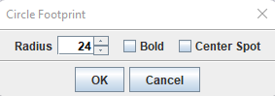
For the point mass footprint, choose circle for most of the tracking needs. At least start with a circle and you can test others for a specific video. You can set the size of the footprint at this stage or resize later.
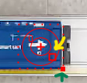
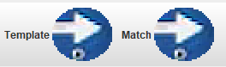
You can adjust the size of the area used as a template for searching/tracking – a yellow arrow in the left figure - and the box of the area for the prediction of motion (useful if object accelerates) – indicated by the green arrow. The result can be seen in the Autotracker window in the template/matching fields.

Theory
Consider the equation 1 that described the dependence of position x on time for the uniformly moving body in the absence of external forces.
$$x=vt+x_{0}\left(1\right)$$
where t is time, v is the velocity and x₀ is the initial position.
You will use Tracker to complete this assignment. The eq. 1 will be useful to identify the velocity in the fit results from Tracker. You will write the report using the format that is described in this manual.

Analysis
Describe the process of fitting and getting average and stdev. Provide the results. Compare them and comment if they are same or not within errors. The format for the results should be like $number±errorunit,i.e.23.4±1.2\frac{m}{s}$

Conclusion
This article describes the format for the lab report and the procedure for the Tracker initial project. List your comments and answers to questions here. If the questions apply more to analysis, the answers can be provided in the analysis section, if they are about theory – in the theory section. If you are unsure, consider a separate ‘answers to questions’ section as a possibility.

References

[1] | L. J. Bignell at al., "Characterization and Modeling of a Water-based Liquid Scintillator," Journal of Instrumentation, IOP Publishing, vol. 10, p. 12009, 12/2015.
[2] | C.W. Walter, "The Super-Kamiokande Experiment," arXiv:0802.1041 [hep-ex], p. 12, 2008.
[3] | Bivar Inc., 4 Thomas, Irvine, CA 92618, USA.

